00 GOLDEN BRAND SYSTEM

Golden Brand Guidelines
A visual and conversational system for a warm, capable family helper.


Everyday connection is the outcome. Original generated concept photograph, illustrating the photography direction.
Golden reduces the mental load by helping family admin reach a clear next step, an agreed action and a confirmed finish. The brand should feel sunny and grown up: a dependable helper that makes room for ordinary, good moments.
This guide sets positioning, colour, type, identity, imagery, message design and conversational behaviour. Use the rules together across the product, campaigns and service touchpoints.
Brand proposal • 2 October 2026
01 GOLDEN BRAND SYSTEM

Positioning and principles
The promise is lighter family life through practical help that gets things done.

Who Golden is for
Parents and carers carrying the work behind family life: remembering, comparing, calling, coordinating and following up. Speak to the person with the task, without assuming their gender, family shape or who is the default parent.

The job Golden takes on
Turn a loose intention into a manageable decision, then take the agreed action and leave a useful record. The emotional benefit follows from the practical one: fewer things to carry, more room to be present.
Value | What people should experience | Proof in the conversation
Share the load | A partner can find the answer and own the next step. | Alex asks Golden, chooses an option and gets a completion receipt.
Your village | Local knowledge becomes a short, useful shortlist. | Recommendations explain the parent feedback, availability and next decision.
Spot what is next | Upcoming admin arrives with preparation already done. | A timely prompt includes options and one clear ask.

Five principles
Warmth has a job. Use welcoming colour and natural language to make a task feel smaller.
Specific beats impressive. Name the task, choices, owner and next step. Let usefulness carry the personality.
Permission stays visible. Ask before booking, spending, changing cover or sharing private information.
A finish is a feeling. Confirm what happened, what remains and who now has the details.
Everyday life is enough. Show school bags, kitchen chats, park afternoons and the little gaps between tasks.

Messaging territory
Primary line: Less to carry. More to be here.
Campaign alternative: Long days. Golden years. Use it with everyday photography, so it speaks to family life rather than retirement or an idealised milestone.
02 GOLDEN BRAND SYSTEM

Colour and contrast
Golden Sun leads. Cream gives it space. Earth anchors the whole system.
These are proposed digital colours drawn from the reference direction. They are not measured matches to a printed swatch, photograph or Pantone standard. Use the hex values consistently; approve print proofs separately.
Colour | Hex | Role
Golden Sun | #FFDE45 | The distinctive brand field, key moments and completion messages
Butter | #F8ECC0 | Quiet secondary panels and gentle emphasis
Cream | #FFFCF4 | The default canvas and breathing room
Earth | #39291E | Primary text, icons, outlines and strong controls
Leaf | #255D46 | Links, completed status and grounded contrast
Sky | #D7EAF0 | Calm supporting surfaces
Clay | #A96A42 | Optional editorial accent, used sparingly

Text pairings
Pair | Ratio | Use
Earth on Cream | 13.57:1 | Body and large text
Earth on Golden Sun | 10.46:1 | Body and large text
Earth on Butter | 11.76:1 | Body and large text
Earth on Sky | 11.20:1 | Body and large text
Leaf on Cream | 7.49:1 | Body and large text
Leaf on Golden Sun | 5.78:1 | Body and large text
Cream on Leaf | 7.49:1 | Body and large text
Clay on Cream | 4.24:1 | Large text only
White on Golden Sun | 1.33:1 | Avoid for text
White on Reply Blue | 4.92:1 | Body and large text

Ratios calculated from proposed sRGB values using WCAG relative luminance. Body target 4.5:1; large text 3:1. Reply Blue #1575B8 is reserved for human chat replies, not the brand palette.
Do: use Earth text on Golden Sun, Butter, Cream and Sky. Do: use Cream text on Leaf. Avoid: white words on yellow, yellow body text on cream, or colour alone to signal completion.
03 GOLDEN BRAND SYSTEM

Type and identity
A full shaped serif brings warmth. A clear sans serif does the everyday work.
Proposed identity specimen. Wordmark uses Fraunces 800. The sunrise disc is a simple supporting mark, not a character.
Role | Typeface and weight | Digital scale | Leading and tracking
Wordmark | Fraunces 800 | 48–88 px | Optical spacing; keep the full word
Marketing hero | Fraunces 500 | 56–84 desktop / 48–72 mobile | 1.05 / −0.025 em
Section heading | Fraunces 500 | 40–62 desktop / 40–44 mobile | 1.12 / −0.015 em
Lede | DM Sans 400 | 20 desktop / 18 mobile | 1.45 / 0
Body and messages | DM Sans 400 | Body 16–18 / dense chat 14 px | 1.45–1.55 / 0
Controls | DM Sans 500 or 600 | 16 px | 1.2 / 0
Label and meta | DM Sans 500 | 12–14 px | 1.3 / +0.03 em

Full shaped rather than childish
Keep Fraunces upright, with generous counters and moderate softness. Use weight 500 for headlines and 800 only for the wordmark. Keep the wording short and the baseline steady. Avoid balloon lettering, stretched letters, exaggerated wobble and a separate playful display face.

Mark and wordmark rules
The mark is a rising half disc above one horizon line. Use it alone for an avatar or small status origin, and with the wordmark when the brand needs identification. Keep clear space equal to the height of the lowercase o. Minimum wordmark width: 96 px digital or 24 mm print. Minimum mark: 24 px. Use Earth on yellow or cream, or Cream on Earth or Leaf. Keep text readable rather than forcing a logo into a tiny chip.
Do not add a face, rays, gradients, outlines around the letters or drop shadows. Do not replace the o with the mark. Final vector lettering and spacing need identity refinement before a permanent logo release.

Font use
Fraunces and DM Sans are available under the SIL Open Font License 1.1. Use official files, retain licence notices when distributing font files, and self host for a predictable product. Fallbacks: Georgia for display and Arial for body. Recheck line breaks whenever a fallback appears.
04 GOLDEN BRAND SYSTEM

Layout and photography
Keep the task clear and give ordinary life room around it.
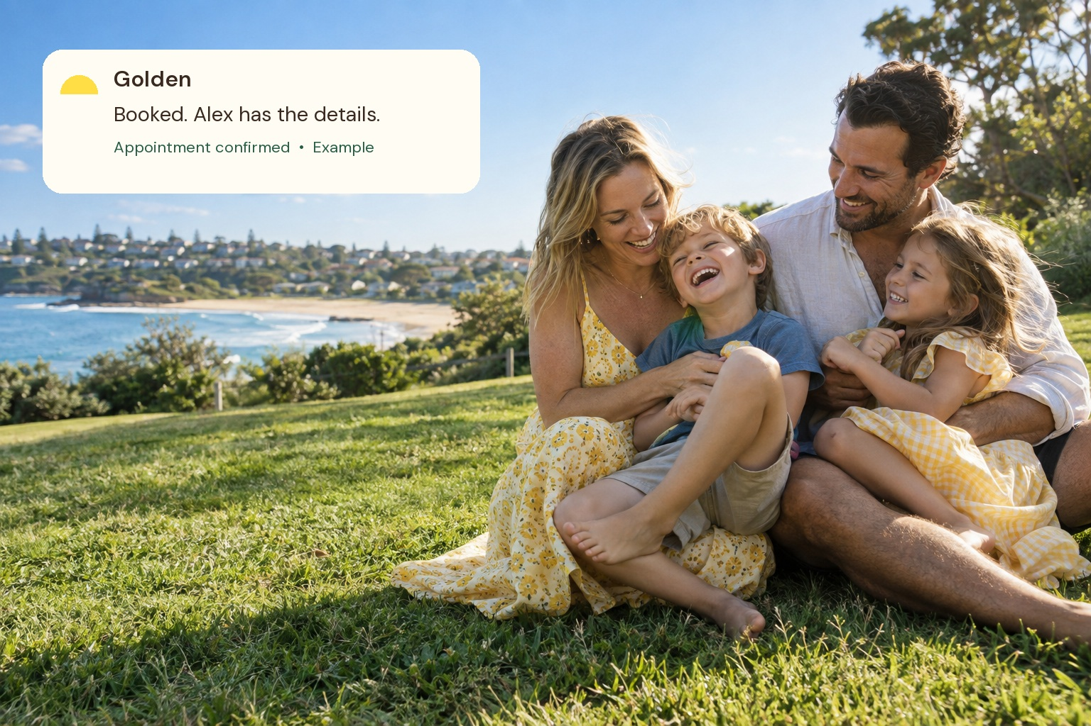
Illustrative notification over the open side of a photograph. The fictional completion message assumes consent to share with Alex.
Surface | Grid and spacing | Use
Desktop page | 1296 px container; 40 px gutters; 1216 px usable | A roomy hero followed by clear sections
Mobile page | 16–24 px gutters; one content column | Headline, one next action, then evidence
Message screen | 16 px gutters; 12–16 px bubble gap | Readable sentences and deliberate reply choices
Cards and controls | 16–24 px padding; 24 px card radius | One task or decision per component
Spacing rhythm | 4, 8, 12, 16, 24, 32, 48, 64, 96 px | Use adjacent steps rather than arbitrary gaps

Photography direction
Candid editorial light, real blue sky, leaf greens, warm skin and earth tones. Yellow can appear in a T shirt, towel or sunlight. Seek ordinary moments: a child leaning into a parent, a carer at the kitchen table, a park after school. Include different family structures and ages across a real campaign.
Crop for the relationship between people, keeping faces and hands intact. Leave quiet space for one small desktop message. On mobile, move the notification below the photograph to protect every face. Keep skin natural and avoid a heavy yellow filter.
Cream is the canvas; flat yellow fields provide recognition. Use a soft Earth shadow only when a floating message needs separation. Keep radii consistent. Leaf and Sky support the nature story.
05 GOLDEN BRAND SYSTEM

Messages and behaviour
Familiar conversation, with clear ownership and permission at the point of action.
Element | Golden treatment | Purpose
Assistant message | Neutral #F0ECE3; Earth text | Proposals and research stay quiet
Human reply | Reply Blue #1575B8 with white text | Make a user decision easy to follow
Conversation canvas | Cream with quiet separators | Keep focus on the task rather than decoration
Action button | Earth with Cream text; 52 px height | One primary decision per message group
Done receipt | Golden Sun, Leaf label and written confirmation | Make a completed action the yellow moment

Use familiar blue and white cues for human replies, with 15 px bubble corners. Keep dense chat at 14 px or larger. Build an original sender header, spacing and mark. Tabs use 14 px type and 44 px minimum height. Do not reproduce another app’s logo, header or exact bubble geometry.

The conversational sequence
Understand. Name the task and ask only for the missing information. Say what you are basing the suggestion on.
Offer. Present a short set of useful options and the tradeoff that helps the person choose.
Agree. Confirm the owner, scope and any payment, cancellation or privacy terms before acting.
Act. Proceed only within the permission given. Surface a new constraint instead of quietly expanding the task.
Finish. Confirm the result, date, destination of the receipt and any follow up. If it failed, say what remains.

The writing rhythm
GOLDEN I found two options. Saturday or Thursday?
SARAH Saturday works.
GOLDEN Shall I book Saturday at 9 am? It is $210 for 12 weeks.
GOLDEN Booked. The school will text your confirmation.
Keep one question at a time. Put the answer first. Use contractions, Australian spelling and concrete dates. Warmth comes from being useful. Skip overfamiliar pet names, guilt, fake celebration and claims about knowing a family better than they know themselves.
06 GOLDEN BRAND SYSTEM

Swimming lessons example
Village knowledge becomes a clear choice, then an agreed booking.
Illustrative product conversation. Harbour Swim is fictional. Price, availability and parent feedback are examples, not verified offers.
GOLDEN Harbour Swim is the highest rated in the local parent feedback I checked. I called them and they have availability next term on Thursdays at 10 am or Saturdays at 9 am. It is $210 for 12 weeks. What day suits you?
SARAH Saturdays.
GOLDEN To book Saturday at 9 am, I need your mobile for the school’s SMS confirmation. Shall I proceed at $210 for 12 weeks?
SARAH [mobile number]. Yep, please book.
GOLDEN Booked. Harbour Swim will text the confirmation to [mobile number].

What makes this Golden
Recommendation with a basis. The assistant explains that the rating came from local parent feedback. A production version names the source, recency and limits of that feedback.
A useful decision. Two available times, one stated price and one question. No long list of schools for the parent to sort out.
Consent in context. The booking ask includes the actual time and price, and explains why the mobile number is needed.
A finish people can use. The message confirms the booking and where the receipt will arrive. Calendar additions or sharing with Alex would need their own existing permission.

Recommended booking receipt fields
Field | Example
Provider and activity | Harbour Swim / term swimming lessons
Time and cost | Saturdays at 9 am / $210 for 12 weeks
Confirmation | Sent by the school to [mobile number]
Follow up | Show the actual cancellation terms and first lesson date

Mia may be used as an example child name in mockups. The user did not supply a child’s name; do not treat Mia as family data.
07 GOLDEN BRAND SYSTEM

Health insurance example
Spot unused value, then put the decision and the permission with the person.
Illustrative product conversation. Banksia Dental is fictional. Benefit amounts, reset dates and appointment availability are unverified example values.
GOLDEN Your policy shows $600 of unused dental extras that reset on 31 December. Would you like me to find dentist availability for you and Alex?
SARAH Yep.
GOLDEN Banksia Dental’s next opening is Wednesday 4 November at 11:40 am. Shall I book, add it to your calendar and share the appointment time with Alex? I will confirm the fee and any out of pocket cost first.
SARAH Sounds good. Book it in and share the appointment details.
GOLDEN Booked. Calendar updated and Alex has the appointment details.

Sharing stays scoped
Consent to share an appointment time does not give permission to share policy details, medical history, treatment or personal financial information. Keep the message to Alex within the agreed scope. Where standing permission exists, the receipt can be shorter: “Booked. Calendar updated and Alex has the details.”

Coverage comparison extension
GOLDEN Your cover includes pregnancy and birth. Would you like me to compare options? I will show prices, waiting periods and benefits that would change before you decide.
SARAH Show me the switch options.
Do not use “Switching will save $3,500 a year” as a product claim without a current, like for like quote and the relevant conditions. If that amount appears in a mockup, label it as an illustrative estimate and show the changed coverage alongside the price.
08 GOLDEN BRAND SYSTEM

Sharing the load example
A partner can take responsibility without asking the other parent to remember everything again.
Illustrative conversation. Mia is an assumed example name. Only authorised shared family information is available to Alex.
GOLDEN Mia’s swim enrolment closes Friday. Can you take this one?
ALEX Have we booked Mia’s swimming for next term?
GOLDEN Not yet. Harbour Swim has Thursday at 10 am or Saturday at 9 am. It is $210 for 12 weeks. Which works?
ALEX Saturday. Use my mobile for the confirmation.
GOLDEN Shall I book Saturday at 9 am for $210 and ask the school to text your confirmation?
ALEX Yes, please book.
GOLDEN Booked. The school will text your confirmation. You own this one.

A handoff transfers the work
A reminder identifies the next owner, then Alex asks the question, chooses and approves the action. Close the loop with him rather than routing the work back to Sarah. “You own this one” needs an agreed task assignment, not a guess about who should do it.

A childcare village example
GOLDEN Little Grove is the most recommended option in the local parent feedback I checked. I called them: they can offer a Thursday tour and discuss two day availability. Shall I book a tour?
Little Grove and the feedback are fictional examples. A real recommendation must show its basis and distinguish parent opinion from verified availability.
The useful output is a tour or a shortlist with the family’s constraints considered. Avoid treating “highest rated” as a fact without the source, review count and date. Always make clear what came from parents, what came from the provider and what still needs checking.
09 GOLDEN BRAND SYSTEM

Spotting what comes next
Prepare enough to make the next conversation small, then give the family a choice.
Illustrative concept for a return to work prompt. No childcare, employment or paid parental leave eligibility has been assessed.
GOLDEN You are six weeks from the return to work date you shared. I have prepared a childcare shortlist and a comparison of the part time options you asked about. Want to see childcare first or the work options?
SARAH Childcare first.
GOLDEN I have two options to check against your days, budget and travel time. Shall I contact them about availability for the week you return?
SARAH Yes, check Tuesdays and Thursdays.
GOLDEN I will check those two days and come back with the answers. For the work comparison, I will separate policy facts from questions to confirm with your employer or Services Australia.

Timing and ownership
Base the prompt on a date the person has shared or an authorised calendar event. Explain why it is timely. Prepare a short result before interrupting. Offer a choice to continue, defer or change the priority. Do not keep sending the same prompt after someone has declined.

Keep certainty honest
“I called” means the call really happened. “Booked” means the provider confirmed it. “I have prepared” means there is an actual result to inspect. Use future tense for planned work and show a pending status when an answer is outstanding.

Campaign lines
Less to carry. More to be here.
The swimming lesson is booked. The park is still yours.
Long days. Golden years.
Pair the promise with a concrete task and an everyday photograph. Avoid framing parents as disorganised or suggesting that the only good family moment is one with all admin finished.
10 GOLDEN BRAND SYSTEM

Components and applications
One clear action, a readable conversation and a finish with enough detail.
Component | Spec | Copy example
Primary action | Earth fill / Cream text / 52 px / pill radius | Book Saturday
Secondary action | Cream / Earth border / same height | Show another option
Suggestion chip | Butter / Earth / 12 px radius / 12–16 px padding | Thursday 10 am
Task card | Cream / Earth / 24 px radius / 24 px padding | Swimming lessons
Status label | Leaf text with an icon and written status | Booked
Input | Cream / Earth / visible focus / 48 px minimum | Your reply

Hero and social layouts
A hero can pair a full Golden Sun headline field with a photograph, or place a Cream message over open sky beside the family. Give the wordmark one clear home. Use one primary action and a short task proof, such as a booking receipt. On mobile, stack the headline, image and proof instead of squeezing them into columns.
For a 1080 × 1350 social post, use a 64 px safe margin and one large thought. Headline: 72–88 px Fraunces 500. Body: 30–36 px DM Sans. For 1080 × 1920, keep important copy in the central 80% and check the actual platform UI before exporting. Use editable live text in the product; image overlays belong in campaign art.

Completion specimen
GOLDEN Booked. Alex has the details.
A good receipt includes | Show when relevant
What happened | Provider, activity and confirmed outcome
When and where | Date, time, address and calendar destination
Cost and conditions | Actual amount, payment status and cancellation terms
Owner and next step | Who has the details and anything still outstanding

What to avoid
No novelty mascots, over rounded lettering or decorative suns on every screen. No unearned checkmarks, fake urgency or broad “everything handled” statements. No long automatic summaries when the person only needs the next decision. Keep completion as specific as the task.
11 GOLDEN BRAND SYSTEM

Production checklist and sources
Use this page before moving a concept into a live product or public campaign.

Ready for production
• Confirm the final name, vector wordmark and sunrise mark. Review similarity and rights before permanent identity release.
• Approve the proposed hex values and test real devices, print proofs and light or dark settings.
• Load the correct Fraunces and DM Sans files. Check fallback wrapping, keyboard focus, zoom, touch targets and all text contrast.
• Verify every stated capability. Research, calls, calendar updates and bookings must match the service actually delivered.
• Replace fictional providers, ratings, benefit amounts, dates, prices, availability and family details with verified information.
• Use actual insurance terms and like for like quotes. Do not publish unverified savings, cover suitability or paid parental leave eligibility claims.
• Show consent before commitments and define what can be shared with a partner. Use the minimum information needed for the task.
• Obtain appropriate licences and releases for campaign photography. Label generated concept imagery where relevant; do not present it as a real customer family.
• Keep Alex, Sarah and Mia as example personas until a real authorised profile supplies the names. Mia was not provided by the user.
• Test the whole journey: task owner, approval, failed action, partial completion, receipt, reminder and opt out.

Reference and provenance
The structure follows the Clear Sky system’s depth and numbered design rules: principles, palette, type, layout, imagery, components and practical do and don’t guidance. Golden has its own warm palette, serif identity and service behaviour. Its colours are proposals, not measured reference matches.
The reference direction combines bright yellow branding, natural blue and green photography, familiar message interactions and human help with family admin. The image in this guide is an original generated concept. All conversations are illustrative product examples.

Official font sources
Fraunces family on Google Fonts
DM Sans family on Google Fonts
Fraunces SIL Open Font License
DM Sans SIL Open Font License
Font sources verified 2 October 2026. Editable text uses the proposed fonts with embedded static font instances. Install the official fonts for the most reliable cross application editing.

